New Philips Ultinon Drive 5000 Series LED – Selective Yellow Lights Deliver Superior Visibility in Fog, Rain, Snow and Dust

Yellow light color helps cut through weather, reduces glare, improves contrast

Las Vegas, NV – Nov. 4, 2024 – Lumileds, a leading lighting solutions company for the automotive industry, has introduced a new line of auxiliary lighting designed to provide off-road vehicles with superior visibility in fog, rain, snow, and dust. Philips Ultinon Drive 5000 Series LED - Selective Yellow lights are available in 3” cube pod lights and 10”, 20”, and 30” lightbars. Featuring a selective yellow color temperature of 3000 K, the lights improve visibility by cutting through fog, dust, and precipitation. The naturally comfortable yellow color helps reduce glare for the driver while optimizing contrast and reducing eye strain.

“Philips designed these innovative yellow lights to combat an issue known as the white wall effect,” notes Jason Dreger, Philips Product Marketing Manager. “In harsh weather conditions, the white lighting typically found on vehicles can reflect off of dust, rain, snow, and fog, creating a ‘white wall’ that makes it even more difficult to see the road. Rather than lighting up the precipitation and dust, Philips Ultinon Drive LED Yellow Lights cut through to improve visibility.”

Lighting options for every need

To provide the ideal lighting conditions for each driver’s need, the Ultinon Drive 5000 Series LED – Selective Yellow 3” cube lights are offered in three configurations: a Spot Beam that delivers up to a 771 foot beam length, a Driving Beam with a beam length of up to 393 feet, and a Flood Beam that offers a beam length of up to 198 feet. The Ultinon Drive LED – Selective Yellow lightbars provide a combination spot/flood beam with a rotating body housing that aims the light beam exactly where it is needed.

Built for the roughest roads

Designed to stand up to rugged off-road travel, the Philips Ultinon Drive 5000 Series LED lightbars and pod lights are built with an extruded aluminum housing, high-strength polycarbonate lenses, and stainless steel mounting brackets. “We’ve built these lights to stand up to the punishment that comes with aggressive off-road driving,” adds Dreger. “They are rated IK07 for resistance to impacts, and IP68/IP69K rated against high pressure water, and the use of aluminum and stainless steel construction make them highly resistant to corrosion.”

Philips Ultinon Drive 5000 Series LED auxiliary lights employ state-of-the-art electronics to avoid electrical interference with other vehicle functions. The lights have been engineered with an aluminum heat sink to prevent LED overheating for longer service life and consistent light output. Additionally, the LEDs feature a spherical lens design that helps focus the light onto the road better than traditional LEDs.

For more information, contact: philipsautoorders@lumileds.com or call 1-866-254-6989.

About Lumileds
Lumileds is a global leader in OEM and aftermarket automotive lighting and accessories, camera flash for mobile devices, MicroLED, and light sources for general illumination, horticulture, and human-centric lighting. Our approximately 5,500 employees operate in over 30 countries and partner with our customers to deliver never before possible solutions for lighting, safety, and well-being. To learn more about our company and solution portfolios, please visit https://lumileds.com.

For further information, please contact:
Aubry Baugh, MBA
Sr. Manager, Aftermarket Marketing Leader, NA
Lumileds
34119 W. 12 Mile Rd., Suite 102
Farmington Hills, MI 48331
Tel: (248) 699-2232
Email: aubry.baugh@lumileds.com

Media Contact:
Jake Spencer
Barolin + Spencer
800-536-6222
jake.spencer@barolin-spencer.com

IMAGE FOR REVIEW ONLY
[Image file:]

Philips Ultinon Drive LED Yellow Lights.jpg

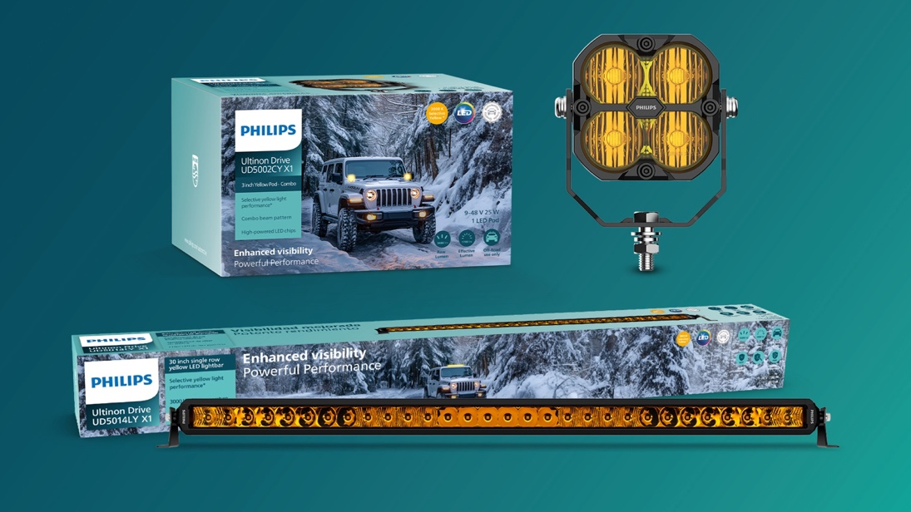

Caption:
Philips Ultinon Drive 5000 Series LED - Selective Yellow provides off-road vehicles with superior visibility in fog, rain, and snow.

304-24/PL5012

