Expanded Philips Xperion 3000 LED Work Lights Line Provides Durable, Versatile, and Affordable Task Lighting

Line now includes 11 lighting choices for Auto Service Pros and DIY Enthusiast.

Las Vegas, NV Nov. 4, 2024– Lumileds, a leading lighting solutions company for the automotive industry, offers the expanded line of Philips Xperion 3000 LED work lights for Pros and DIYers. The Xperion 3000 LED line includes 11 work lights, 10 of which are powered by rechargeable lithium batteries. Designed for durability, reliability, and affordability, Xperion 3000 LED work lights include convenient features that make the lights a welcome addition in the shop, around the house, and in the garage.

What type of LED work lights does Phillips offer?

The Philips Xperion 3000 LED work light includes seven hand-held lights, two flood projector lights, an under-hood light, and a wearable headlamp. Each of these lights were designed to provide excellent visibility while working in the engine bay or around the vehicle.

Ranging from the sleek Pen Eco or Penlight these work lights function similarly to a traditional flashlight but in a much compact form. The two Xperion 3000 flood lights are perfect for lighting up larger spaces and are equipped with three output modes. When it comes to tight spaces the Xperion 3000 “Slim” is a hand-held light that features a folding light panel and a 270-degree tiltable light module. For those that like to get their hands dirty, the Xperion 3000 “Headlamp” is a wearable headband work light with two light sources and three output modes. Finally, the latest addition to the offering is the Under Bonet (Under Hood) light. The Under-Bonnet LED light offers a powerful, bright light of 1200 lumens that can be mounted under the hood or bottom of the vehicle.

What are some of the some of the design features of the Xperion 3000 work lights?

Each of the Xperion 3000 lights are IP rated for resistance to impact, water, and dust. Their grip surfaces retain excellent grip even in the presence of grease and oils. Many of the Xperion 3000 work lights are equipped with integrated magnets and 360° rotating hooks, leaving hands free for the job. The long lasting battery supply will allow individuals to finish most jobs without interruption.

According to Aubry Baugh, Senior Manager, Aftermarket Marketing Leader, NA, “Our newly expanded Philips Xperion 3000 LED work lights line provides professional quality and lighting performance at price points that most any DIYer can afford. We have seen strong demand for the lights as they represent an excellent combination of value, quality, and performance. And now we offer even more versatile lighting options.”

For more information, email: philipsautoorders@lumileds.com or call 1-866-254-6989.

About Lumileds
Lumileds is a global leader in OEM and aftermarket automotive lighting and accessories, camera flash for mobile devices, MicroLED, and light sources for general illumination, horticulture, and human-centric lighting. Our approximately 6,000 employees operate in over 30 countries and partner with our customers to deliver never before possible solutions for lighting, safety, and well-being. To learn more about our company and solution portfolios, please visit https://lumileds.com.

For further information, please contact:
Aubry Baugh
Senior Manager, Aftermarket Marketing Leader, NA
Lumileds
34119 W. 12 Mile Rd., Suite 102
Farmington Hills, MI 48331
Tel: (248) 699-2202
Email: aubry.baugh@lumileds.com

Media Contact:
Jake Spencer
Barolin + Spencer
800-536-6222
jake.spencer@barolin-spencer.com

[Image file:]
Philips Xperion 3000 LED Work Lights.jpg

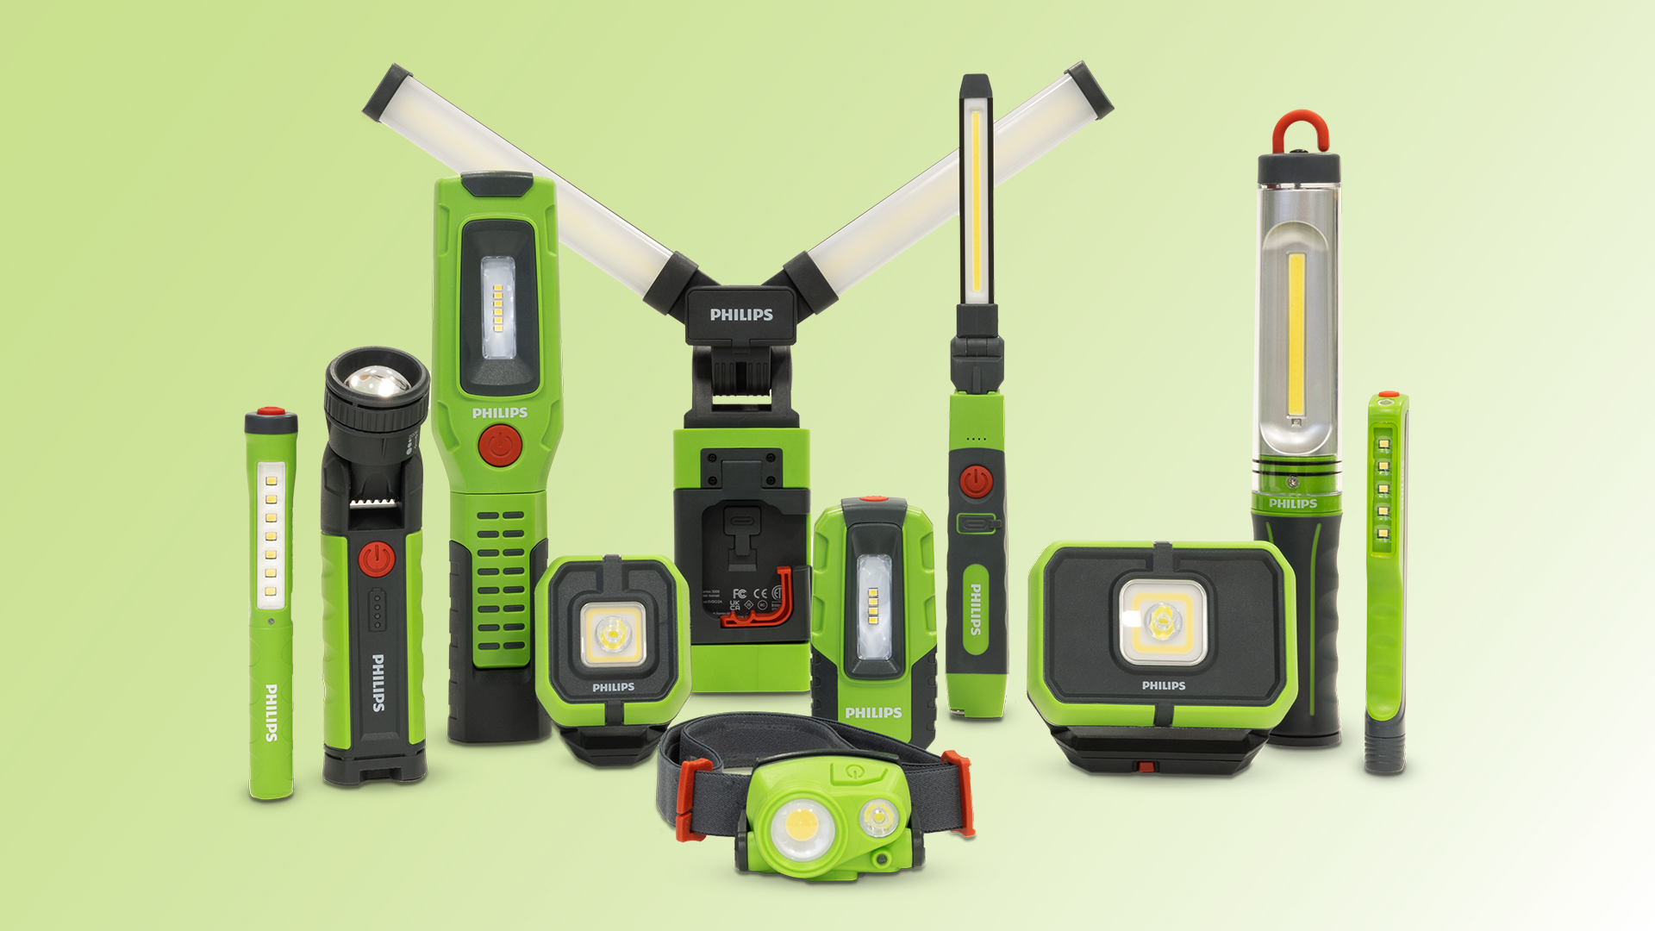

[Caption:]

Philips Xperion 3000 LED work lights deliver quality and affordability for the shop and the home.

315-24/PL5012

