New Philips Ultinon Essential Next Gen II LED headlights make upgrading to LEDs easier than ever before

The headlight bulb’s compact design and compatible base mean broader compatibility

Las Vegas, NV – Nov. 4, 2024– Lumileds, a leading lighting solutions company for the automotive industry, has just made moving up from halogen headlights to LEDs quicker and easier than ever before. New Philips Ultinon Essential Next Gen II LED headlights have the same size and form factor as the halogen bulbs they replace. That means there’s no need for adapter rings or concerns about fitting in vehicles with very tight under hood spaces. The new headlights and fog lights are available as direct replacements for a wide range of bulbs including 880, 881, 9003/H4/H19, 9004, 9005/9006, 9007, 9008, 9012, H1, H3, H7/H18, H11/H9, H15, H8/9145/H16, and PS24W/PSX24W. Philips Ultinon Essential Next Gen II LED headlights will be available for our Canadian and Mexican markets.

Bright white beam for enhanced vision

With a bright white color temperature of 6000 Kelvin, Philips Ultinon Essential Next Gen II LED headlights provide a clearer view of the road. This helps drivers spot potential hazards earlier, giving them more time to react, for better nighttime driving safety.

Advanced cooling technology for longer service life

Powerful LEDs produce high heat levels that can reduce light output and shorten bulb life. Ultinon Essential Next Gen II LED headlights incorporate Philips AirCool technology for active heat dissipation. A cooling fan built into the base of the bulb draws heat away from the LED driver electronics. As a result, the bulbs offer up to 1,500 hours of service life – three times the lifespan of equivalent halogen bulbs. The active cooling fan is supplemented by an innovative heat sink design that’s integrated into the bulb. This advanced heat management helps ensure

rock-solid reliability and homogeneous, uniform light output throughout the bulb’s operating life.

Industry compliant

Philips Ultinon Essential Next Gen II LED headlights have been engineered to comply with automotive industry standards for electromagnetic interference (EMI). They integrate seamlessly with the electrical systems of most vehicles and won’t disrupt the vehicle’s other electrical systems.

Fast, easy installation

Philips Ultinon Essential Next Gen II LED headlights install exactly like the halogen bulbs they replace. There’s no need for compatibility checks or outboard electronics. The bulbs feature polyvalent or flexible center rings for cross-compatibility with a variety of headlight bulb socket styles. According to Jason Dreger, Philips Product Marketing Manager, “Installing Ultinon Essential Next Gen II LED bulbs is no different than installing a conventional halogen bulb. The procedure and the amount of time it takes are exactly the same.”

For more information, contact: philipsautoorders@lumileds.com or call 1-866-254-6989.

About Lumileds
Lumileds is a global leader in OEM and aftermarket automotive lighting and accessories, camera flash for mobile devices, MicroLED, and light sources for general illumination, horticulture, and human-centric lighting. Our approximately 5,500 employees operate in over 30 countries and partner with our customers to deliver never before possible solutions for lighting, safety, and well-being. To learn more about our company and solution portfolios, please visit https://lumileds.com.

For further information, please contact:
Aubry Baugh, MBA
Sr. Manager, Aftermarket Marketing Leader, NA
Lumileds
34119 W. 12 Mile Rd., Suite 102
Farmington Hills, MI 48331
Tel: (248) 699-2232
Email: aubry.baugh@lumileds.com

Media Contact:
Jake Spencer
Barolin + Spencer
800-536-6222
jake.spencer@barolin-spencer.com

[Image file:]

Philips Ultinon Essential Gen II.jpg

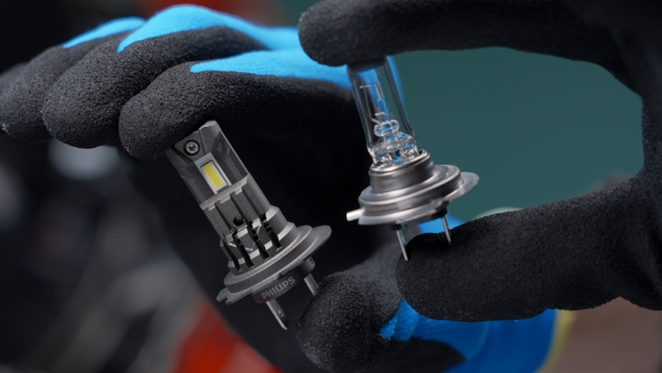

[Caption:]
Philips Ultinon Essential Next Gen II LED headlights have same size and form factor as the halogen bulbs they replace.

45-24/PL5046

